Macro-SEL Protection System
Version 0.1
Radiation-Tolerant Latch-up Detection and Recovery
Edge Computer for LEO Orbit
3-Year Minimum Mission Requirement
February 2026

Table of Contents
Part 1: Macro-SEL Protection Design Overview 4
1. Introduction 4
2. System Architecture 4
2.1 Protection Strategy 4
3. Power Budget 4
3.1 Input Power 4
3.2 Protected Rails 4
3.3 Protection Circuit Power Consumption 5
4. Major Components 5
4.1 Master Protection Switch 5
4.2 Op-Amps 5
4.3 Comparators 5
5. Wired-AND Architecture 6
5.1 Principle of Operation 6
6. Control Logic 6
6.1 Blanking Window (10ms Inrush Masking) 6
6.2 SR Latch (Fault State Memory) 6
6.3 Retry Timer 6
6.4 Enable Logic 6
7. Bill of Materials Summary 7
7.1 Active Components (9 ICs total) 7
8. Default power tree 7
9. Proposed power tree 8
Part 2: Complete Single Rail Diagram 9
10. Current Sensing Stage 9
10.1 Shunt Resistor 9
10.2 Difference Amplifier 10
11. Voltage Reference Generation 10
12. Comparator Stage 11
13. Wired-AND Bus 11
14. Blanking Gate 12
15. Blanking Timer 13
16. SR Latch 14
17. Retry Timer 14
18. Retry Pulse Generation 16
19. Enable Logic 16
20. P-FET Gate Driver 17
Reference 17

Part 1: Macro-SEL Protection Design Overview

1. Introduction
This document describes the Macro-SEL (macro single-event latch-up) protection system for a space-qualified edge computer designed for Low Earth Orbit (LEO) missions with a minimum 3-year operational requirement.
The system protects ARM Cortex-A72 CPUs, AI cores, DDR4 RAM, and eMMC storage built on advanced process nodes using commercial off-the-shelf (COTS) components rather than radiation-hardened alternatives.

2. System Architecture

2.1 Protection Strategy
The system employs a hardware-only autonomous protection approach:
• One master P-channel MOSFET (high-side, 5V input rail)
• Six independent current-sensing channels (one per downstream rail)
• Wired-AND comparator bus (any fault triggers global fault)
• Hardware-only infinite retry: ~1 second off between attempts
• 10ms blanking window after FET turn-on (masks inrush)
• SR latch maintains fault state during power loss

3. Power Budget

3.1 Input Power
5V @ 5A maximum from the power source (25W total system budget)

3.2 Protected Rails
Rail | Voltage | Current | Load | Shunt | Trip Threshold
1 | 3.3V | 5A | AI Core 1 | 10 mΩ | 7.5A (150%)
2 | 3.3V | 5A | AI Core 2 | 10 mΩ | 7.5A (150%)
3 | 1.2V | 3A | CPU + DDR4 | 10 mΩ | 4.5A (150%)
4 | 1.35V | 0.4A | CPU | 50 mΩ | 0.6A (150%)
5 | 1.8V | 2A | CPU + eMMC | 10 mΩ | 3.0A (150%)
6 | 2.5V | 1A | CPU + DDR4 | 10 mΩ | 1.5A (150%)
Note: Rail 4 uses 50mΩ shunt (v4.0 change) to reduce voltage drop from 40mV to 20mV, saving critical margin for 1.35V rail.

3.3 Protection Circuit Power Consumption
All protection circuits powered from 5V_IN (single power domain):
• 2× OPA4H838-SEP op-amps: 5.2 mA
• 2× TLV1704-SEP comparators: 0.3 mA
• 5× Logic ICs (SN54SC series): 0.1 mA
• V_ref dividers (5 total): 0.5 mA
• Wired-AND pull-up resistor: 0.5 mA
• Total: ~6.6 mA @ 5V = 33 mW (0.13% of system budget)

4. Major Components

4.1 Master Protection Switch
Q1: BUP06CP038F-01 P-channel MOSFET
• Package: DPAK (TO-252AA)
• V_DSS: -55V
• I_D: -35A continuous, -140A pulsed
• R_DS(on): 38 mΩ typ @ Vgs = -4.5V
• TID: 30-50 krad(Si)
• SEE LET: 46 MeV·cm²/mg

4.2 Op-Amps
U_AMP_A, U_AMP_B: OPA4H838-SEP (quad op-amp)
• Package: CFP-14 hermetic flatpack
• Supply: 2.5V - 5.5V (powered at 5V from 5V_IN)
• GBW: 10 MHz (4× improvement over LMP7704-SP)
• Slew rate: 5 V/µs (5× improvement)
• Input offset: ±2.25 µV (200× better than LMP7704-SP)
• Offset drift: ±0.005 µV/°C (zero-drift technology)
• Input CM range: -0.1V to 5.1V (excellent headroom for 3.3V rails)
• TID: 30 krad(Si) RLAT
• SEE LET: 43 MeV·cm²/mg

4.3 Comparators
U_CMP_A, U_CMP_B: TLV1704-SEP (quad comparator)
• Package: TSSOP-14
• Supply: 2.2V - 24V (powered at 5V from 5V_IN)
• Propagation delay: 560 ns typical
• Output type: Open-drain (critical for wired-AND operation)
• TID: 30 krad(Si) RLAT
• SEE LET: 43 MeV·cm²/mg

5. Wired-AND Architecture
The design employs a critical architectural simplification using open-drain comparator outputs in a wired-AND configuration.

5.1 Principle of Operation
All six comparator outputs are tied together to a single bus wire with one 10kΩ pull-up resistor to 5V. This creates an inherent AND function:
• When ALL comparators are Hi-Z (no faults): Bus pulled HIGH by resistor → GLOBAL_FAULT = HIGH
• When ANY comparator drives LOW (fault detected): Bus pulled to GND → GLOBAL_FAULT = LOW

6. Control Logic

6.1 Blanking Window (10ms Inrush Masking)
A critical feature to properly handle input capacitor charging inrush:
• Triggered by ENABLE_GLOBAL rising edge (when FET turns ON)
• Duration: 9.5ms - 15.5ms (RC timing with component variation)
• Implementation: 10nF capacitor + 1MΩ resistor + Schmitt trigger
• Function: Masks fault detection during inrush period

6.2 SR Latch (Fault State Memory)
Remembers fault occurrence even after rails collapse to 0V:
• IC: SN54SC4T00-SEP (quad 2-input NAND)
• Active-LOW inputs: SET_L and RESET_L
• Output: ENABLE GLOBAL (fault remembered)
• Critical function: Prevents immediate restart when rails collapse

6.3 Retry Timer
Holds system off for ~1 second after fault shutdown:
• RC circuit: 1.0MΩ + 2.2µF
• Delay range: 0.7s - 1.7s (component variation)
• Discharge transistor: Q_dis (JANSR2N3700UB NPN)
• Controlled by ENABLE_GLOBAL output

6.4 Enable Logic
Matches logic coming out of the latch to the logic driving P-MOSFET gate
• Just one inverter gate

7. Bill of Materials Summary

7.1 Active Components (9 ICs total)
Component | Part Number | Function | Qty
Q1 | BUP06CP038F-01 | Master P-FET | 1
U_AMP | OPA4H838-SEP | Quad op-amp | 2
U_CMP | TLV1704-SEP | Quad comparator | 2
U_LATCH | SN54SC4T00-SEP | Quad NAND (latch) | 1
U_OR | SN54SC4T32-SEP | Dual OR (blanking) | 1
U_SCH | SN54SC6T17-SEP | Hex Schmitt buffer | 1
U_INV | SN54SC6T14-SEP | Hex Schmitt inverter | 1
Q_dis | JANSR2N3700UB | NPN transistor | 1

8. Default power tree
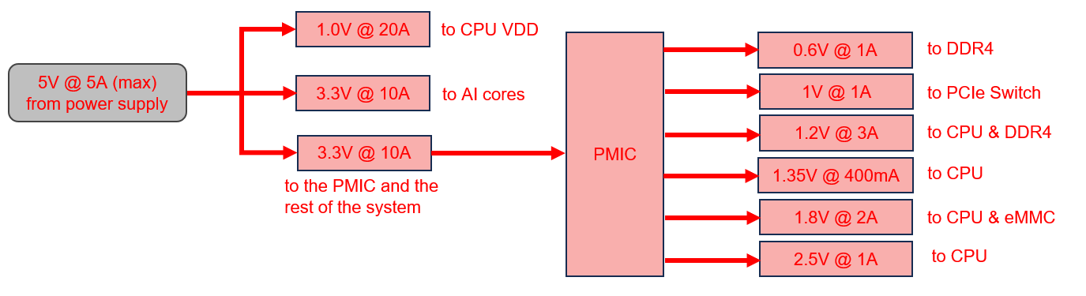

9. Proposed power tree
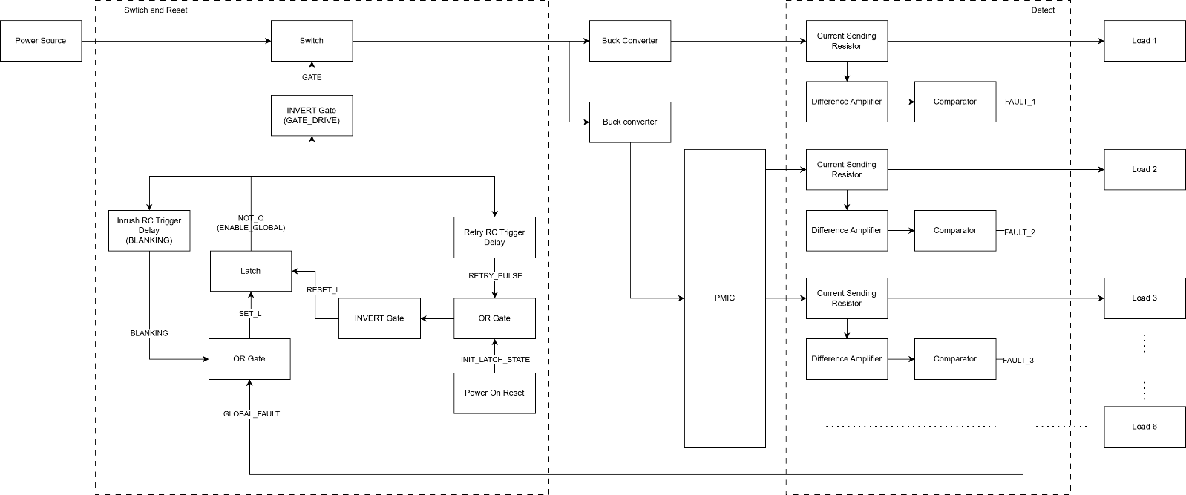

Part 2: Complete Single Rail Diagram
This section provides a complete detailed diagram for one rail showing the entire signal path from power input to the P-FET gate driver.
Rail specifications:
• Voltage: 3.3V
• Rated current: 5A
• Trip threshold: 7.5A (150% of rated)

10. Current Sensing Stage

10.1 Shunt Resistor
The shunt resistor converts rail current into a measurable voltage drop:
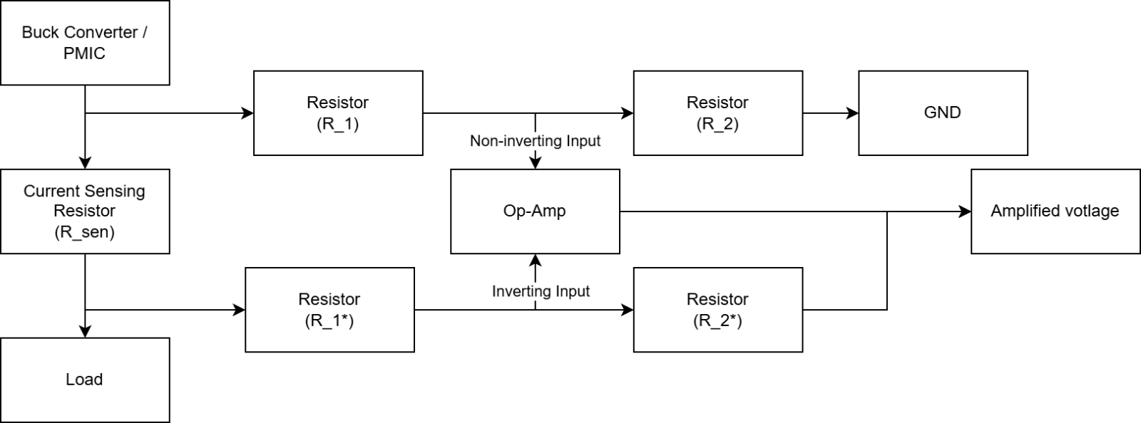
Component: WSL2512R0100FEA
- Resistance: 10 mΩ ± 1%
- Power rating: 2W
- Package: 2512 SMD with 4-wire Kelvin connection
Voltage drops:
• Normal (5A): V_drop = 5A × 10mΩ = 50mV (1.5% of 3.3V rail)
• Trip threshold (7.5A): V_drop = 7.5A × 10mΩ = 75mV
NOTE: consider using 0.1% tolerant resister

10.2 Difference Amplifier
4-resistor instrumentation amplifier topology converts small differential voltage into larger single-ended signal:
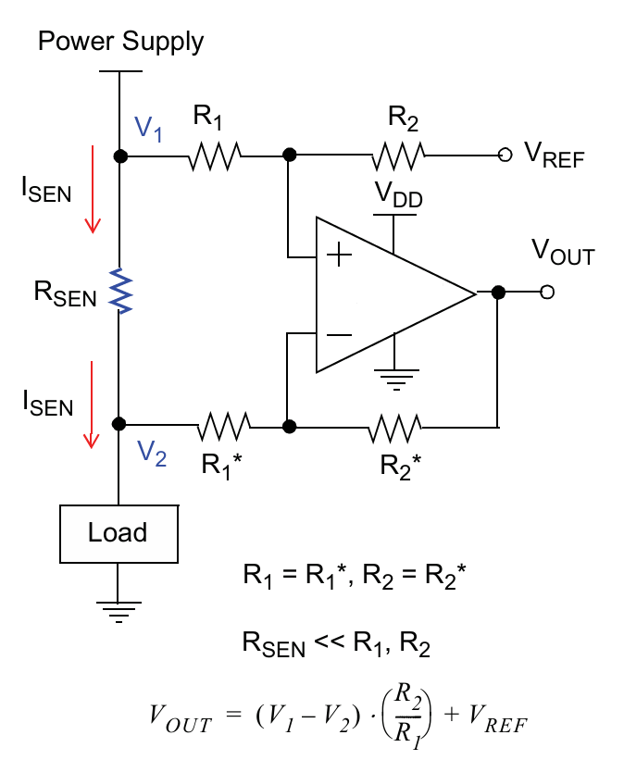
Component: OPA4H838-SEP
The main concern of using the op-amp is the rated differential voltage between its two inputs. The OPA4H838-SEP is rated at +-0.2V differential limit. The concern is that op-amp inputs might exceed +-0.2V during transients. In those cases, the protective diode inside the op-amp fails and start conducting. So, it’s imperative that the currents flowing into those inputs are limited to prevent melting the op-amp.
In the worst case, the voltage at the op-amp inputs is 3.3V and with R_1 is 10kOhm, the maximum current is only 330uA and the dissipating power is 1.1mW. That is negligible. The protective structures in op-amps are typically rated to handle several milliamps continuously, and the transient duration here is microseconds, so the thermal stress is even smaller than the steady-state calculation implies.
To simplify the design of the comparison circuitry, all amplified current sensing voltage will be compared to the same reference voltage which is set to roughly 1V. So, the gain between different rails needs to be set differently.
Rail | I_trip | R_sen | V_sen | Gain_ideal | R2 (selected) | Gain_actual | V_trip
1 | 7.5A | 10mΩ | 75mV | 13.33 | 133kΩ | 13.18 | 988mV
2 | 7.5A | 10mΩ | 75mV | 13.33 | 133kΩ | 13.18 | 988mV
3 | 4.5A | 10mΩ | 45mV | 22.22 | 221kΩ | 21.90 | 985mV
4 | 0.6A | 50mΩ | 30mV | 33.33 | 332kΩ | 32.90 | 987mV
5 | 3.0A | 10mΩ | 30mV | 33.33 | 332kΩ | 32.90 | 987mV
6 | 1.5A | 10mΩ | 15mV | 67.67 | 665kΩ | 65.89 | 988mV
Rail 4 supplies 1.35V to the CPU. The CPU is sensitive to supply voltage and requires that the delivered voltage stay within ±5% of nominal, which is a tolerance window of ±67.5mV. Between the PMIC output and the CPU, voltage is dropped by three series elements: the shunt resistor, PCB trace resistance, and connector resistance. Unlike the shunt resistor, trace and connector resistance can be minimised through careful PCB layout, so the shunt resistor's contribution should be kept as small as possible.
A 10mΩ shunt on a 0.6A trip current produces only 6mV at the sense input, requiring a difference amplifier gain of 167 to reach the 1.0V comparator threshold. With the OPA4H838-SEP's 10 MHz GBW, this gives a bandwidth of 59.9 kHz and a theoretical output rise time of 5.84µs, a significant delay for a circuit whose purpose is to detect and interrupt fast macro-SEL events.
A 50mΩ shunt on the same 0.4A rated current produces a 20mV voltage drop at the load, consuming 30% of the ±67.5mV tolerance budget and leaving 47.5mV for trace and connector resistance. The required gain drops to 33.3 theoretically, giving a bandwidth of 300 kHz and an output rise time of 1.17µs, a 5× improvement in detection speed over the 10mΩ option.

Bandwidth and response time:
• GBW = 10 MHz (OPA4H838-SEP)
• BW = GBW / Gain
• t_rise = 0.35 / BW
Rail | Gain_actual | BW | T_rise
1 | 13.18 | 759kHz | 0.46µs
2 | 13.18 | 759kHz | 0.46µs
3 | 21.90 | 457kHz | 0.77µs
4 | 32.90 | 304kHz | 1.15µs
5 | 32.90 | 304kHz | 1.15µs
6 | 65.89 | 152kHz | 2.3µs
The op-amps are powered directly from the power source, the always-on domain upstream of the master P-FET. This ensures the sensing and detection logic remains active and in a deterministic state throughout both shutdown and the recovery hold period.

11. Voltage Reference Generation
V_ref provides the threshold voltage for fault detection. Target is ~1.0V to match V_AMP at 150% current.
NOTE: Rails 1 & 2 share ONE V_ref divider (both are 3.3V/5A with identical trip points).
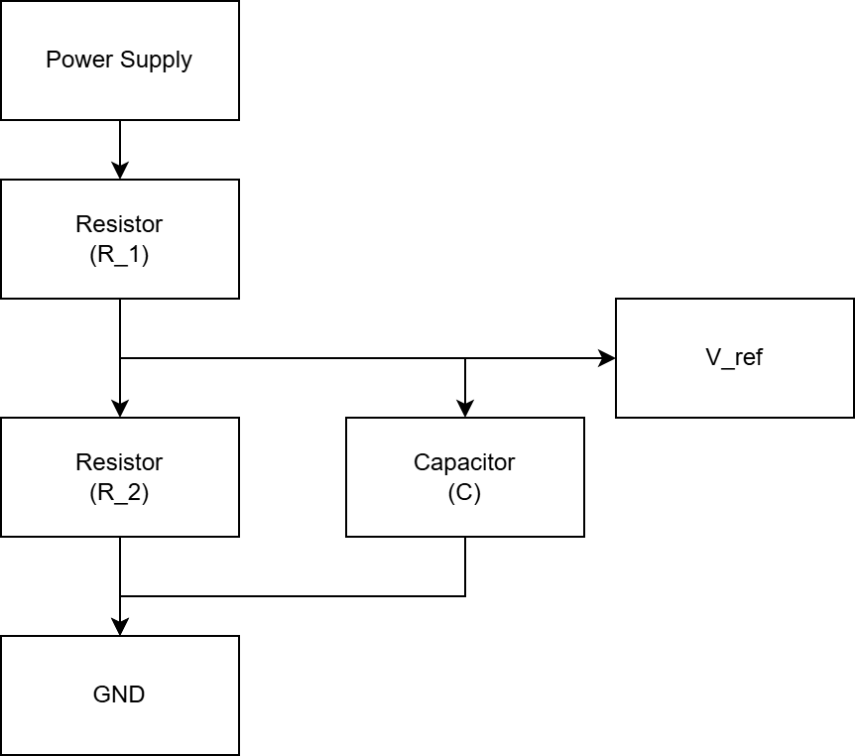

12. Comparator Stage
TLV1704-SEP comparator with open-drain output detects when amplified signal exceeds threshold:
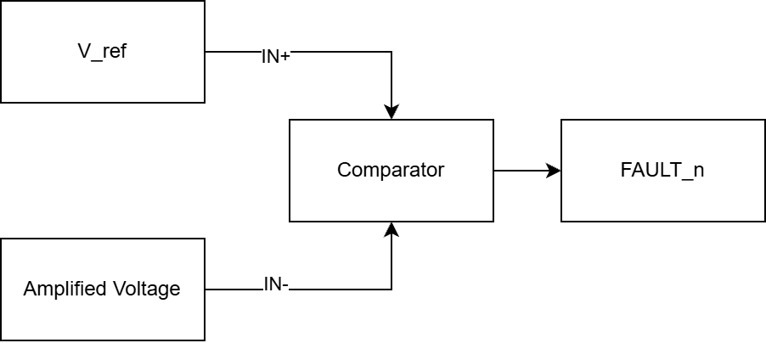
Comparator logic:
• IN+ = V_ref
• IN- = V_AMP_1 (variable, tracks rail current)
Operation:
• Normal: V_AMP_1 < V_ref → IN+ > IN- → Output Hi-Z
• Fault: V_AMP_1 > V_ref → IN+ < IN- → Output drives LOW

13. Wired-AND Bus
All 6 comparator outputs tied together with single 10kΩ pull-up resistor:
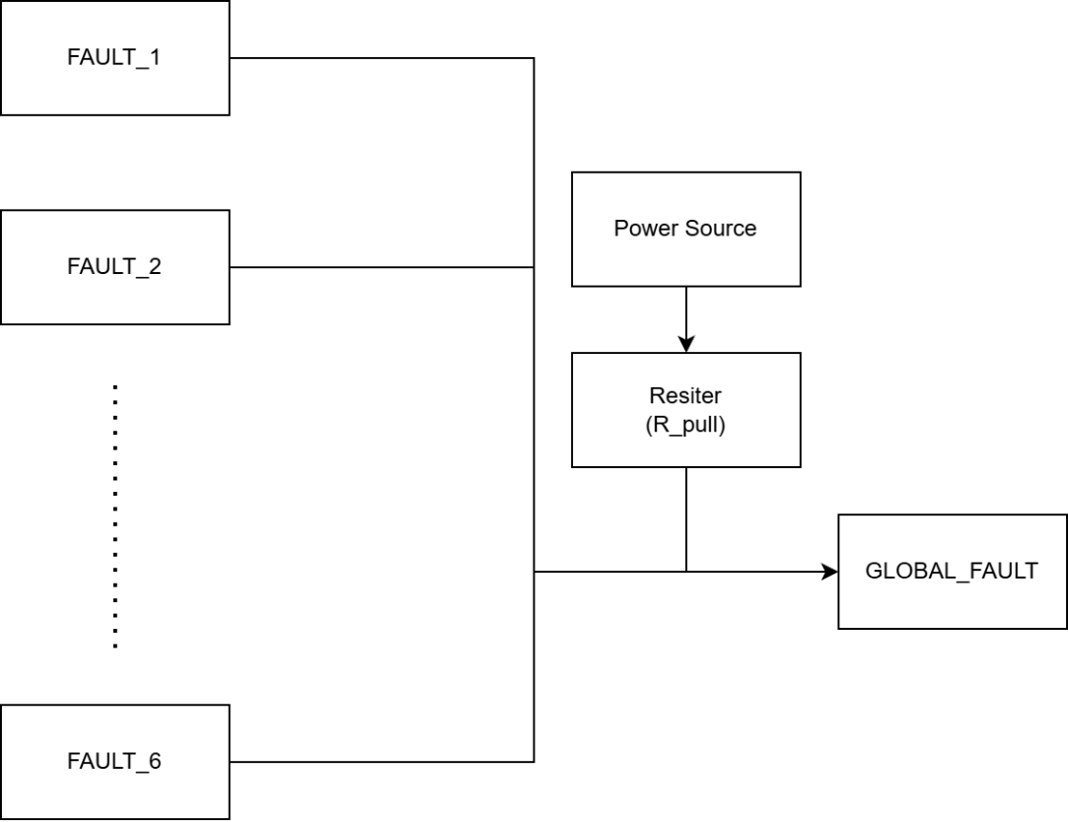

Bus signal states:
• ALL rails normal (all 6 comparators Hi-Z): Bus = HIGH (~5V)
• Rail 1 faults (comparator 1 drives LOW): Bus = LOW (~0V)
• Multiple rails fault: All share pull-down current, bus = LOW
• During shutdown (all V_AMP = 0V): Comparators Hi-Z, bus = HIGH (false indication, but SR latch remembers fault)

14. Blanking Gate
OR gate combines fault signal with blanking timer to mask faults during inrush:
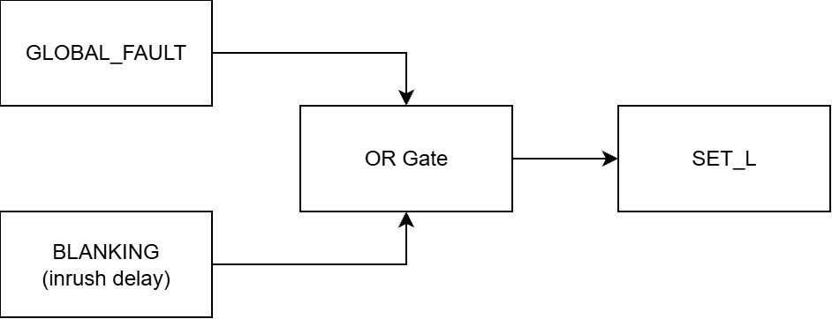
Truth table:
GLOBAL_FAULT | BLANKING | SET_L
HIGH | HIGH | HIGH (Startup: faults masked)
HIGH | LOW | HIGH (Normal: no fault)
LOW | HIGH | HIGH (Inrush fault: MASKED)
LOW | LOW | LOW (Real fault: trigger latch)
Critical function: During 10ms blanking window, even if inrush triggers GLOBAL_FAULT = LOW, the OR gate keeps SET_L = HIGH (inactive), preventing false shutdown.

15. Blanking Timer
Generates 10ms HIGH pulse starting when ENABLE_GLOBAL rises (FET turns ON):
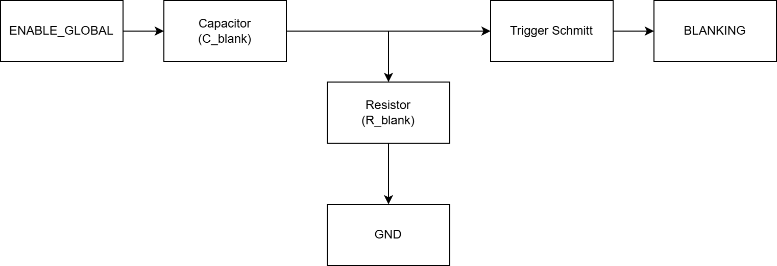
Operation:
- The Rising Edge (FET Turns ON): When ENABLE_GLOBAL transitions from LOW to HIGH, the fast-rising edge contains high-frequency AC components. The 10nF capacitor acts momentarily as a short circuit to this edge, coupling the voltage spike directly to Trigger Schmitt input.
- Triggering: Trigger Schmitt’s input instantly spikes high (around 3.5V). Because this is well above the Schmitt buffer's positive-going threshold V_T+, the buffer's output (BLANKING) snaps HIGH immediately.
- The Discharge Phase: Once ENABLE_GLOBAL settles at a steady 5V (DC), the capacitor blocks the DC current. The voltage at input of the Trigger Schmitt now discharges down to 0V through the 1 MΩ resistor. The RC time constant is 10ms (1 MΩ * 10nF).
- The Falling Edge (Window Closes): As the voltage at the input of the Trigger Schmitt decays, it eventually crosses the Schmitt trigger's negative-going threshold V_T-, roughly 1.06V). The buffer's output (BLANKING) snaps LOW, effectively ending the blanking window after approximately 9.5ms to 15.5ms.
When ENABLE_GLOBAL goes from HIGH to LOW (FET turns OFF), the capacitor couples that negative edge. However, Trigger Schmitt’s input is already resting at 0V. The negative spike has no effect on the Schmitt trigger's positive-logic output, so no false blanking pulse is generated during shutdown.
Logic Integration:
This active-HIGH BLANKING pulse is fed into an OR gate alongside the active-LOW GLOBAL_FAULT signal. During the ~10ms window, the HIGH BLANKING signal forces the OR gate's output (SET_L) to remain HIGH, completely overriding any LOW fault signals triggered by the inrush current.

16. SR Latch
Cross-coupled NAND gates remember fault state during power loss:
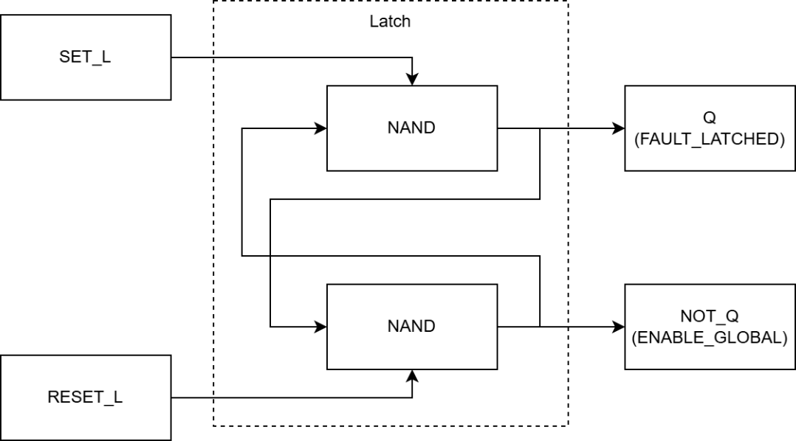
IC: SN54SC4T00-SEP (quad 2-input NAND), uses gates 1 and 2
Operation:
2 NAND gates make an active LOW SR latch
SET_L | RESET_L | Action | FAULT_LATCHED | ENABLE_GLOBAL
HIGH | HIGH | Hold (no change) | Previous state | Previous state
LOW | HIGH | SET (latch fault) | HIGH | LOW
HIGH | LOW | RESET (clear fault) | LOW | HIGH
LOW | LOW | Invalid (avoid) | Undefined | Undefined
Logic integration:
When rails collapse to 0V, GLOBAL_FAULT goes HIGH, but latch holds FAULT_LATCHED = HIGH or ENABLE_GLOBAL = LOW, keeping system off until retry timer resets it.

17. Retry Timer
Holds system off for roughly 1 second after fault shutdown then the system turns on:
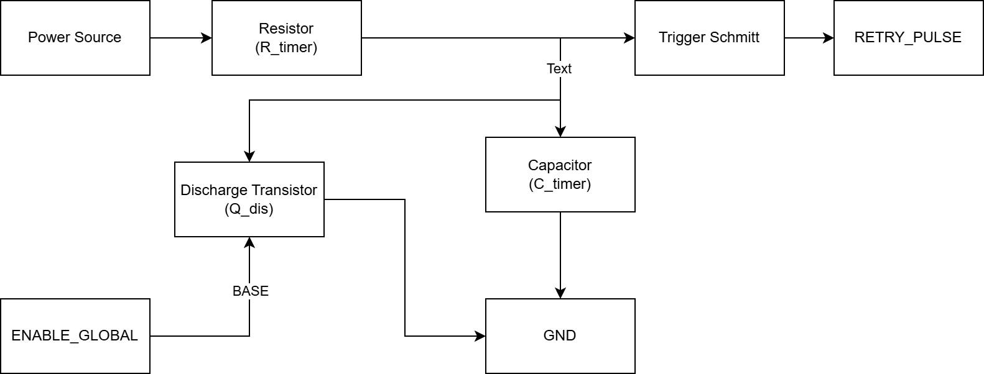

Operation:
The RC Timing
The idea of this delay is a simple analog RC timing circuit, controlled by the logic state of the system.
- The Timer: Formed by R_timer (1.0 MΩ) and C_timer (2.2 µF) making a RC differentiator.
- The Switch: Q_dis (the NPN transistor) acts as an electronic valve that either holds the timer at zero or lets it run.
- The Reader: The Trigger Schmitt buffer (SN54SC6T17-SEP) monitors the capacitor's voltage and snaps cleanly to a HIGH logic state only when a specific voltage threshold is reached.
Phase 1: Normal Operation (System is running)
During normal operation, the timer should be disabled so it isn't constantly trying to reset the system.
- ENABLE_GLOBAL is HIGH (no fault).
- This HIGH signal hits the base of the discharge transistor (Q_dis), turning it ON.
- The transistor shorts the capacitor directly to GND. The voltage at the Schmitt trigger input stays clamped at 0V, keeping RETRY_PULSE LOW.
Phase 2: A Fault Occurs (The Delay Starts)
When a latch-up event is detected, the system shuts down and needs to wait for the latch-up current to dissipate before turning back on.
- ENABLE_GLOBAL snaps LOW.
- The LOW signal turns the discharge transistor OFF.
- With the short to ground removed, the 5V power source begins charging the 2.2uF capacitor through the 1.0MΩ resistor.
- The Math: the RC time constant is R_timer x C_timer = 2.2s. The voltage rises slowly along the RC charge curve.
Phase 3: The Threshold is Reached (The Retry)
- The Schmitt trigger is watching the rising voltage on the capacitor.
- Depending on the exact IC tolerances, its positive-going threshold V_T+ will be somewhere between 1.43V and 2.71V (typically 2.00V).
- It takes roughly 0.7 to 1.7 seconds for the charging capacitor to hit this voltage.
- The instant it crosses V_T+, the Schmitt trigger's output (RETRY_PULSE) snaps HIGH.
Logic Integration:
The RETRY_PULSE signal then passes through an INVERT gate before feeding into the RESET_L of the SR latch. This is because that the latch is active low.
- RETRY_PULSE (HIGH pulse) → Inverter → RESET_L (LOW pulse)
- SR latch sees LOW on RESET_L → resets to ENABLE_GLOBAL = HIGH

18. Power on Reset
Sets the initial state of the latch as when first powering on, the output of the latch is indeterministic, and the latch’s output is used to control the blanking window and the retry reset. In the ideal case, the ENABLE_GLOBAL should snap from LOW to HIGH, which turns on the FET, stops the retry circuit from restarting the system and triggers the blanking. If the ENABLE_GLOBAL stays LOW, the FET stays off, the system won’t turn on, however, since the ENABLE_GLOBAL is LOW, the retry reset starts charging and after roughly 1s, it will send the reset signal to the latch and let the system on.
For a reliable way to turn on the system, the Power on Reset circuitry will send a pulse to RESET_L of the latch to properly reset the latch every time power is first delivered to the system.
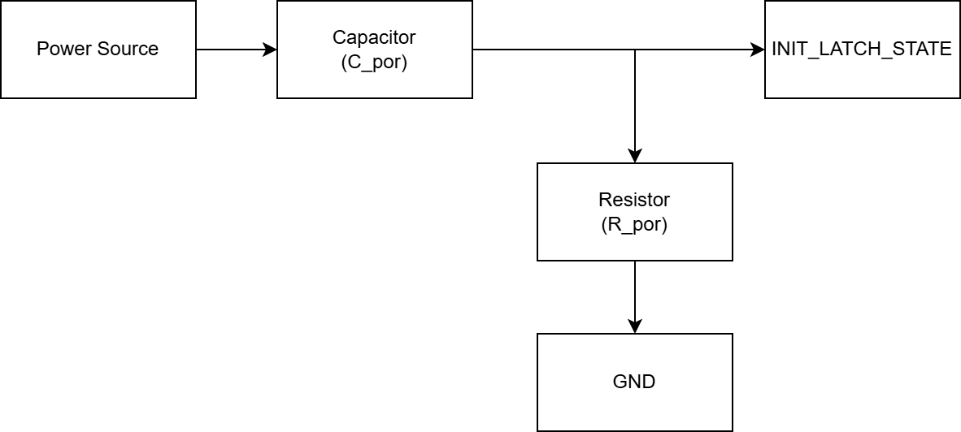
Operation:
- Before plugging in the system to the power source, INIT_LATCH_STATE = 0V.
- When power is connected and starts rising, the fast-rising edge contains high-frequency AC components. The 100nF capacitor acts momentarily as a short circuit to this edge, coupling the voltage spike directly. INIT_LATCH_STATE spikes HIGH.
- Once power settle, the capacitor blocks the DC current. 100nF C_por discharges through 100kΩ R_por, making INIT_LATCH_STATE decays to 0V
- The RC time constant is R_por x C_por = ~10ms (much longer than needed for latch reset)
Logic Integration:
The INIT_LATCH_STATE signal then passes through an INVERT gate before feeding into the RESET_L of the SR latch. This is because that the latch is active low.
- INIT_LATCH_STATE (HIGH pulse) → Inverter → RESET_L (LOW pulse)
- SR latch sees LOW on RESET_L → resets to ENABLE_GLOBAL = HIGH

19. Reset Logic
An OR gate to combine the 2 reset signals from the retry delay and the power on reset.
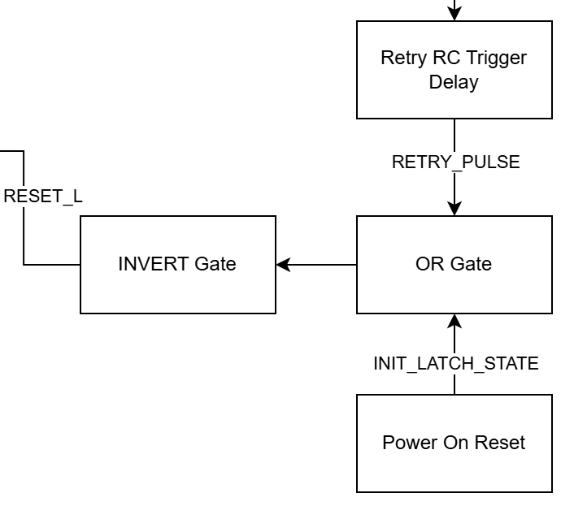
Operation:
RETRY_PULSE | INIT_LATCH_STATE | RESET_L
LOW (no fault) | LOW (stable power) | HIGH (work normal)
HIGH (turn on after fault) | LOW (stable power) | LOW (restart after fault)
LOW (no fault) | HIGH (first power up) | LOW (first power up)
HIGH (turn on after fault) | HIGH (first power up) | LOW (first power up)
Logic integration:
On power up, the latch gets reset and during that window, all the fault signals are masked, once power becomes stable, the power on reset circuitry is essentially disable. The masking window during first power up matches with the blanking window, so the logic is unchanged.

20. P-FET Gate Driver
Inverts ENABLE_GLOBAL and drives P-channel MOSFET gate:
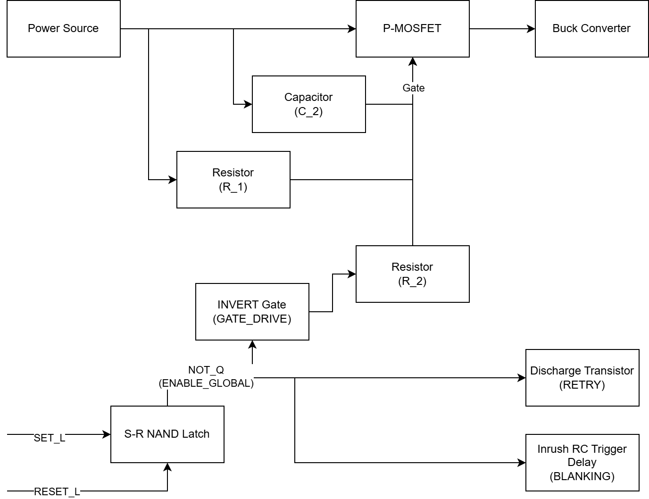
Gate driver logic:
- ENABLE_GLOBAL = HIGH: GATE_DRIVE = LOW → Vgs = -5V → FET ON
- ENABLE_GLOBAL = LOW: GATE_DRIVE = HIGH → Vgs = 0V → FET OFF
Gate circuit components:
- R1 (10kΩ): Pull-up to 5V, ensures fail-safe OFF if driver loses power
- R2 (100Ω): Series resistor limits gate current, controls dV/dt
- C2 (100nF): Gate-to-source snubber reduces ringing
Switching timing:
- Gate RC, RC time constant: τ = 100Ω × 2.5nF (C_GS) = 250ns
- Turn-on time: ~500ns (3× time constant)
- Turn-off time: ~500ns
Note: C2 traces should be as short as physically possible, connecting directly between the Gate pad and Source pad of P MOSFET

Reference
RC Trigger Schmitt delay circuit: https://blog.mbedded.ninja/electronics/circuit-design/delays/
AN1332 Current Sensing Circuit Concepts and Fundamentals: 01332b.pdf
Space-Grade, 100-krad, Discrete, Three Op Amp Instrumentation Amplifier Circuit: snoaa71.pdf

